top – this command is used to check the process which are running

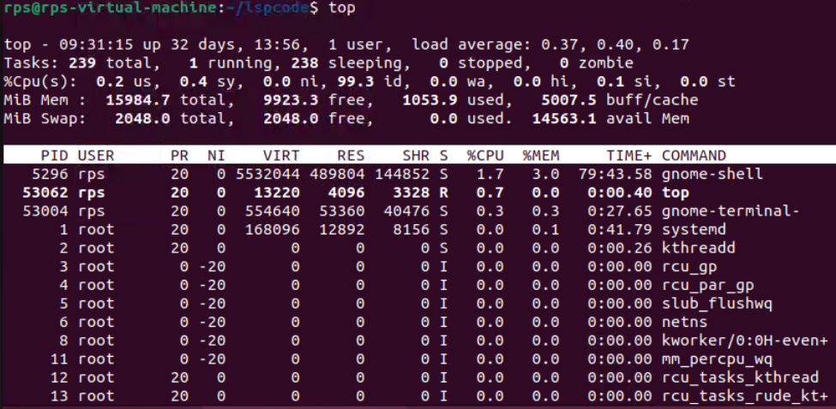

htop- check process running with more options

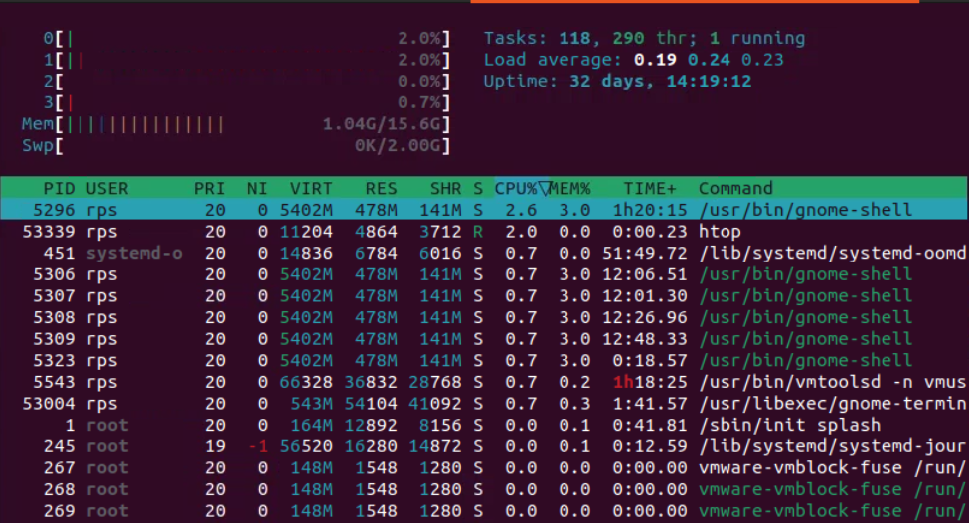

ps – stands for process status , it allows you to view information about the process running on the system.



ps –u

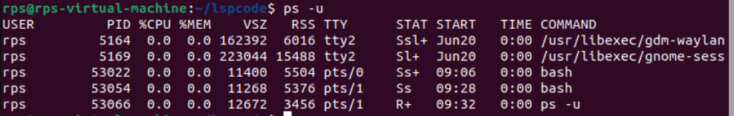

ps –ef | grep test_loop



Kill – kills the running process

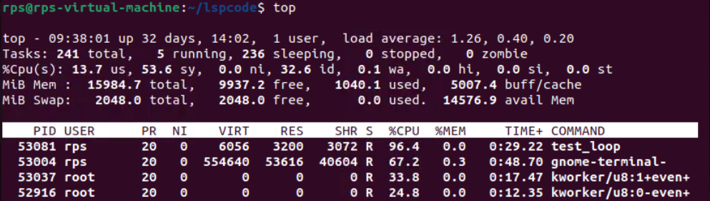

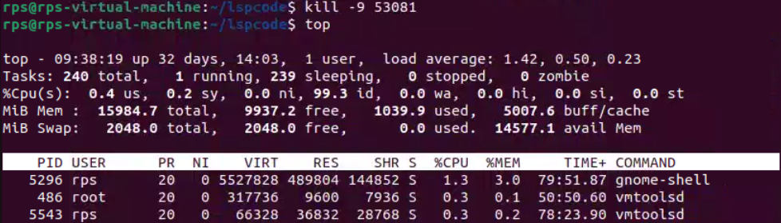

Killall – terminates the process by command name

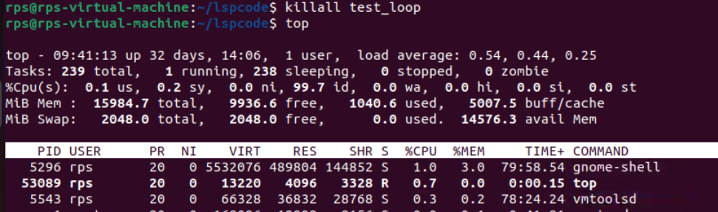

Kill –l

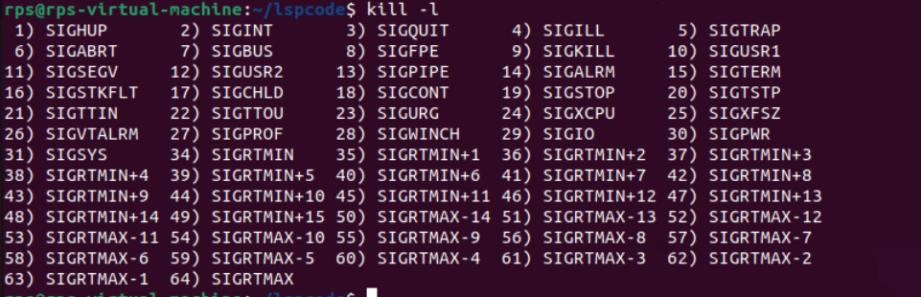

First script

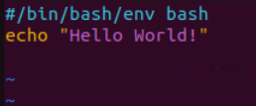

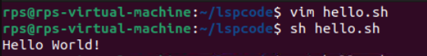

File hello1.sh

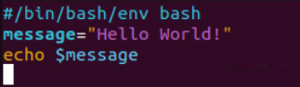

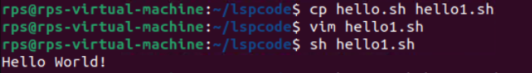

File hello2.sh

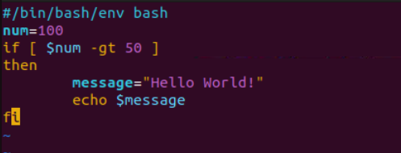

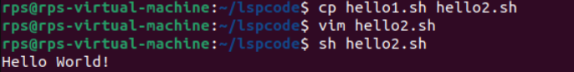

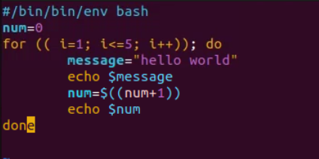

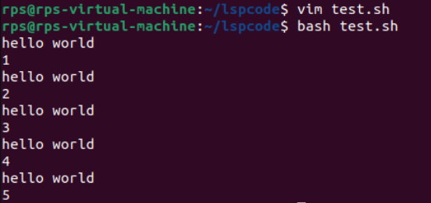

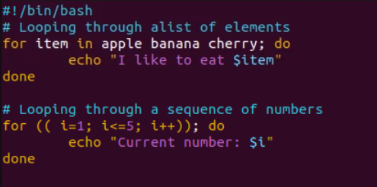

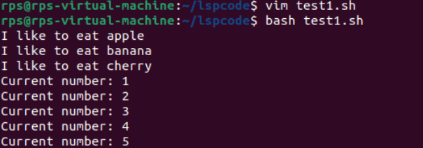

Exercise 1:

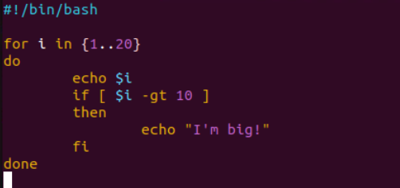

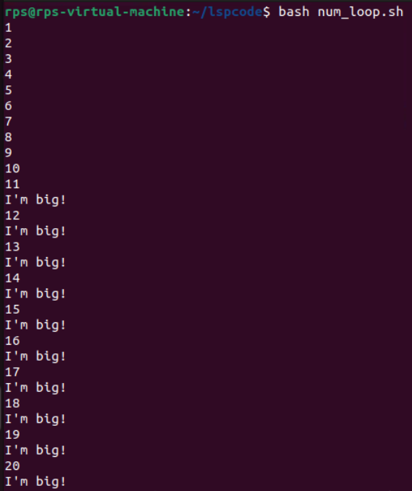

Exercise 2:

File mcd.sh

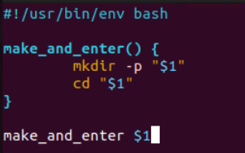

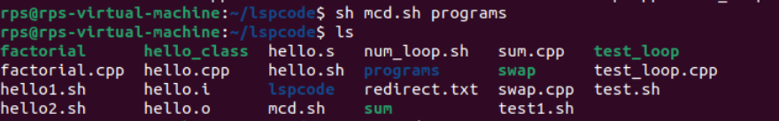

Exercise 3:

File my_folder.sh

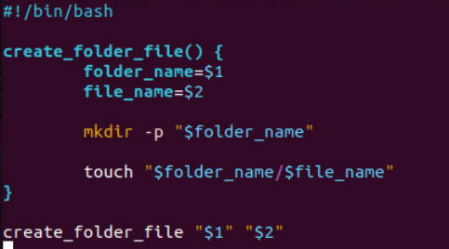

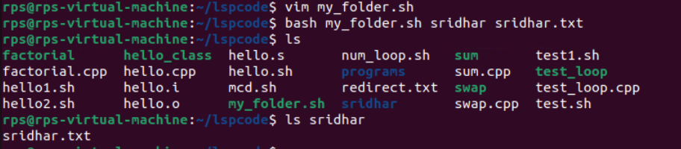

File Search:

Write a command to find all files with the extension .txt in the /home directory and its subdirectories.

find /home –type f –name “*.txt”

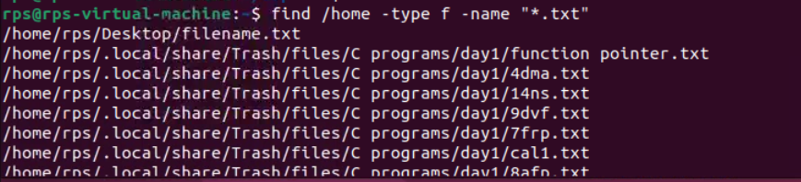

File Permissions:

Write a command to change the permissions of all files in the /var/log directory to 644.

find /var/log –type f –exec chmod 644 {} \;

Disk Usage:

Write a command to display the disk usage of all directories in the /home directory in a human-readable format.

du –h –max-depth=1 /home



Process Management:

Write a command to list all running processes that contain the name "apache" in their command line.

Ps aux |grep apache



Text Processing:

Write a command to count the number of lines in a file named error.log.

Wc –l error.log



Network Configuration:

Write a command to display the IP address of all network interfaces on the system.

ip address

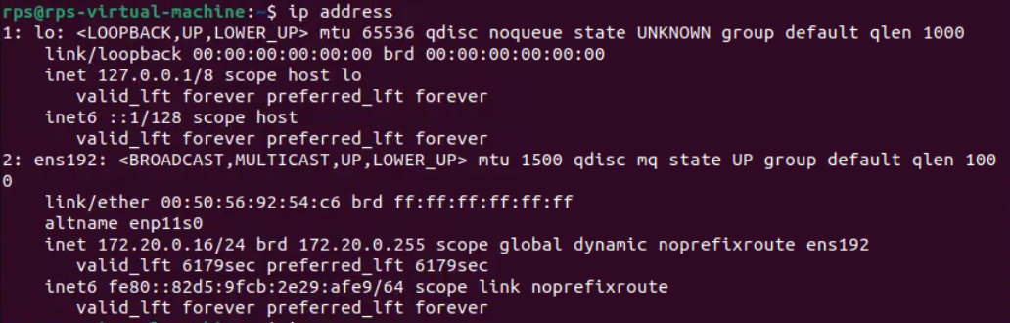

Package Management:

Write a command to install a package named htop using the package manager.

Sudo apt install htop

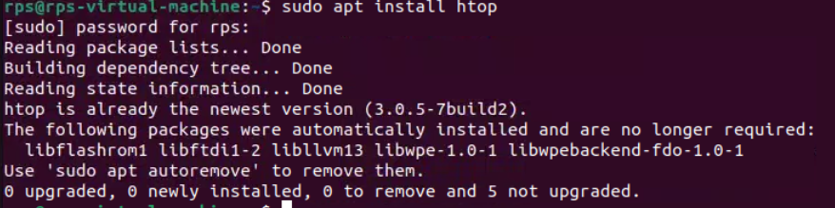

User Management:

Write a command to add a new user named developer to the system.

Sudo adduser developer

File Compression:

Write a command to compress a directory named backup into a .tar.gz file.

tar –czvf backup.tar.gz backup

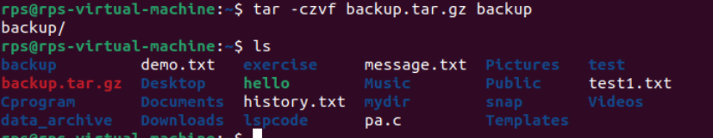

System Monitoring:

Write a command to display real-time system resource usage, including CPU, memory, and disk I/O.

Top or htop

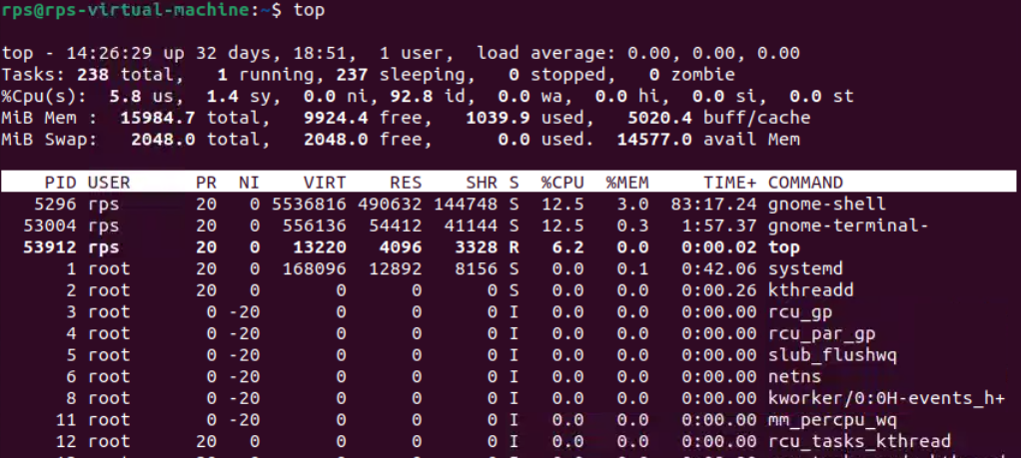

Shell Scripts

Backup Script:

Write a shell script to back up a directory named /data to /backup with the current date appended to the backup file name.

File backup_script.sh

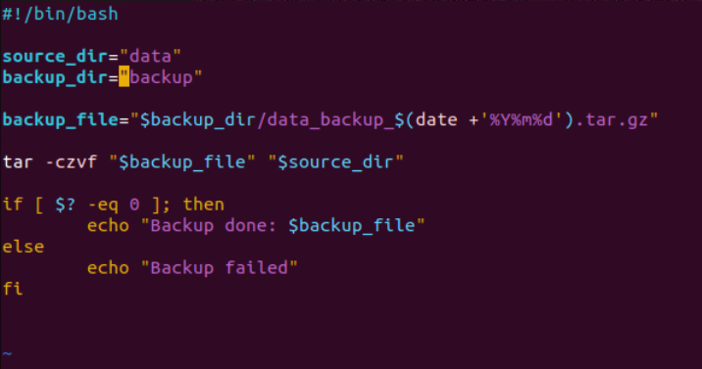

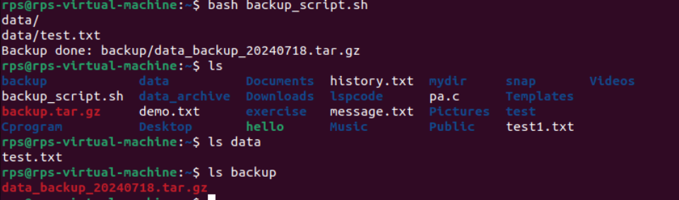

Log Rotation:

Write a shell script to rotate log files in the /var/log directory, keeping only the last 7 days of logs.

User Report:

Write a shell script to generate a report of all users currently logged into the system and save it to a file named user_report.txt.

File user_report.sh

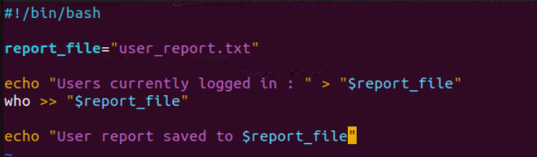

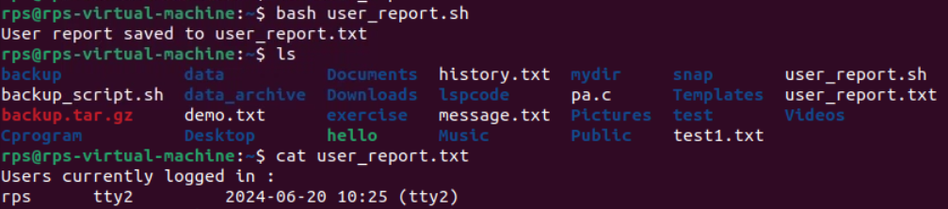

Disk Space Alert:

Write a shell script to check the disk usage of the /home directory and send an email alert if the usage exceeds 80%.

File wmail.sh

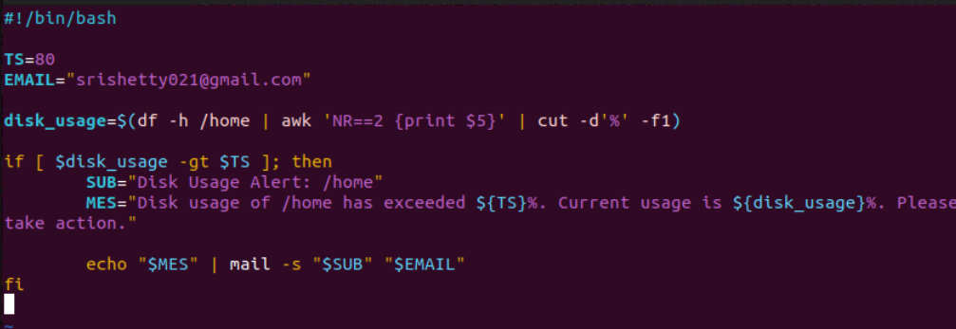



Service Monitor:

Write a shell script to check if the nginx service is running and restart it if it is not.

File smnginx.sh

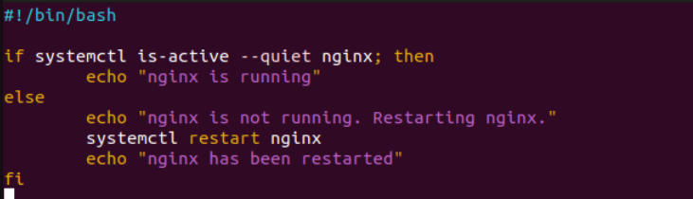

File Cleanup:

Write a shell script to delete all files older than 30 days in the /tmp directory.

File fclean.sh

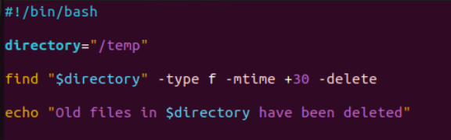

Automated Updates:

Write a shell script to automatically update all installed packages on the system.

File auto_update.sh

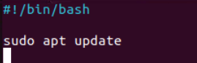

Database Backup:

Write a shell script to back up a MySQL database named sales to a file named sales_backup.sql.

System Information:

Write a shell script to display system information, including hostname, OS version, and kernel version.

File sinfo.sh

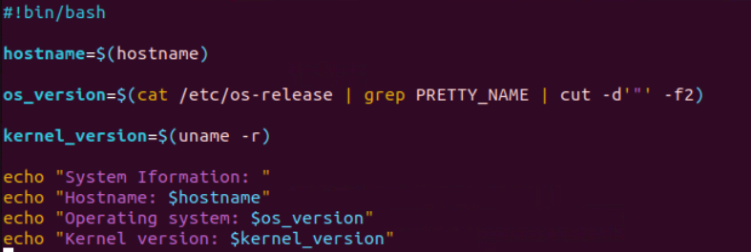

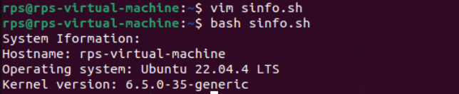

Cron Job:

Write a shell script to schedule a cron job that runs a specific command every day at midnight.